Task 2- DDL Constraints

Create a database called “Sales” and create a new table named “Orders” in the Sales database with columns: (Order_Id, Customer_name, Product_Category, Ordered_item, Contact_No).   
Use constraints:  

* Primary Key
* Unique
* Not Null

1. Add a new column named “order_quantity” to the orders table.    
2. Rename the orders table to the sales_orders table.   
3. Insert 10 rows into the sales_orders table.   
4. Retrieve customer_name and Ordered_Item from the sales_orders table.   
5. Use the update command to change the name of the product for any row.   
6. Delete the sales_orders table from the database.

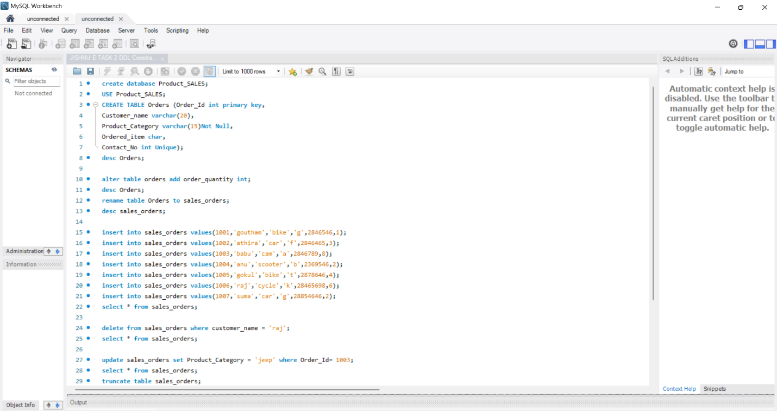

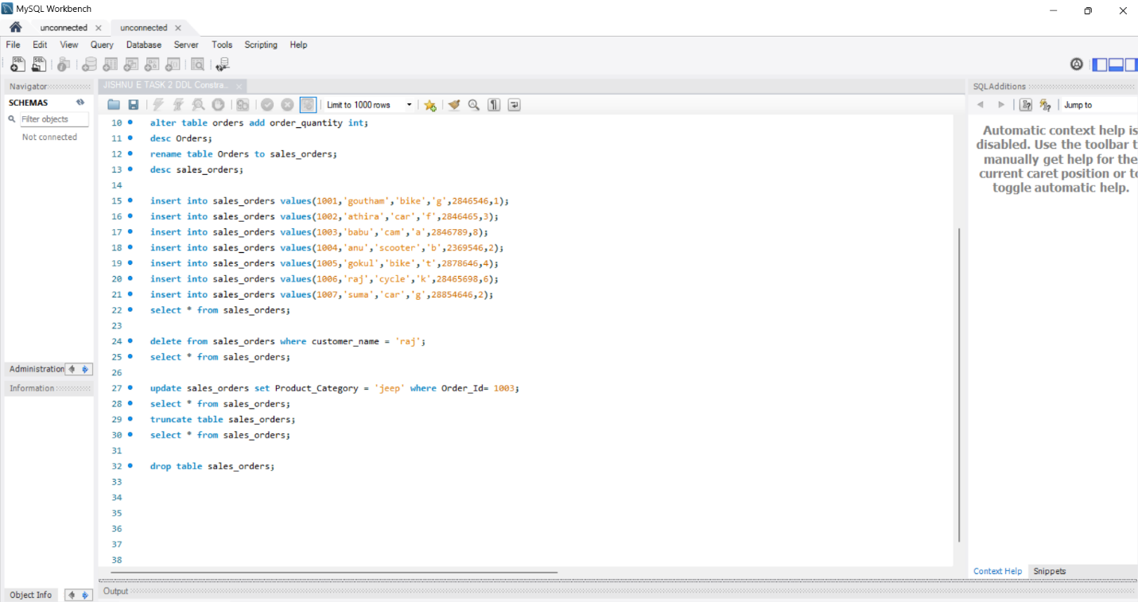

create database Product_SALES;

USE Product_SALES;

CREATE TABLE Orders (Order_Id int primary key,

Customer_name varchar(20),

Product_Category varchar(15)Not Null,

Ordered_item char,

Contact_No int Unique);

desc Orders;

alter table orders add order_quantity int;

desc Orders;

rename table Orders to sales_orders;

desc sales_orders;

insert into sales_orders values(1001,'goutham','bike','g',2846546,1);

insert into sales_orders values(1002,'athira','car','f',2846465,3);

insert into sales_orders values(1003,'babu','cam','a',2846789,8);

insert into sales_orders values(1004,'anu','scooter','b',2369546,2);

insert into sales_orders values(1005,'gokul','bike','t',2878646,4);

insert into sales_orders values(1006,'raj','cycle','k',28465698,6);

insert into sales_orders values(1007,'suma','car','g',28854646,2);

select * from sales_orders;

delete from sales_orders where customer_name = 'raj';

select * from sales_orders;

update sales_orders set Product_Category = 'jeep' where Order_Id= 1003;

select * from sales_orders;

truncate table sales_orders;

select * from sales_orders;

drop table sales_orders;